Features of H.265 (HEVC) and their differences between AVC

Abstract
HEVC, proposed as the successor to AVC in 2013, still cannot shake AVC's dominant position in the market to this day. This can be attributed to its high patent costs, royalties, complex patent ownership, and the substantial computational power required. Therefore, even before HEVC has become widespread, MPEG has already started organizing the next generation H.266 (VVC), while other open-source encoding/decoding standards like AV1 are also continuously innovating, unwilling to fall behind. In this short tutorial, we will briefly introduce several new features and the differences between HEVC and AVC from High level syntax to entropy coding.

High Level Syntax Elements and Units

Clean Random Access (CRA):
IDR in AVC flushes frame buffer while CRA does not. Therefore, leading pictures of CRA can reference the frames before CRA, as the RASL shown in Fig. 1, to reach better compression rate. S is for “skippable” while D is for decodable. RASL is skipped when the random access applied.
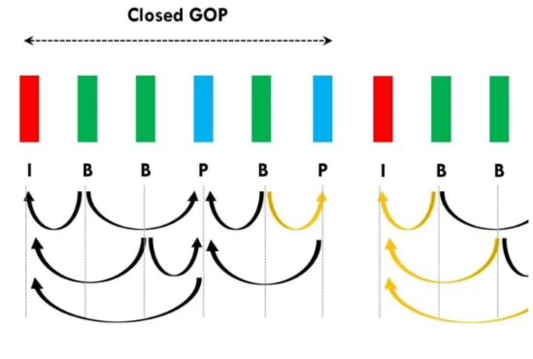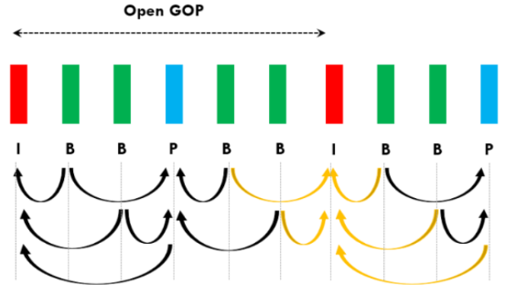
IDR CRA
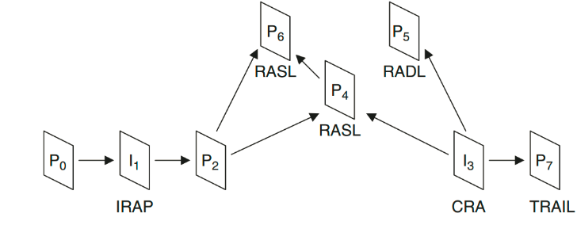
Fig. 1 Differences between IDR and CRA [1, 2].

Coding Tree Unit (CTU):
Similar to the macroblock in AVC. In AVC, MB can be 16x16, 16x8, 8x16, 8x8, 8x4, 4x8, 4x4, While in HEVC, CTU can be of size 64x64, 32x32, 16x16. Each CTU can be further partitioned into 4 square Coding Units (CUs). The minimum size of CU is 8x8.
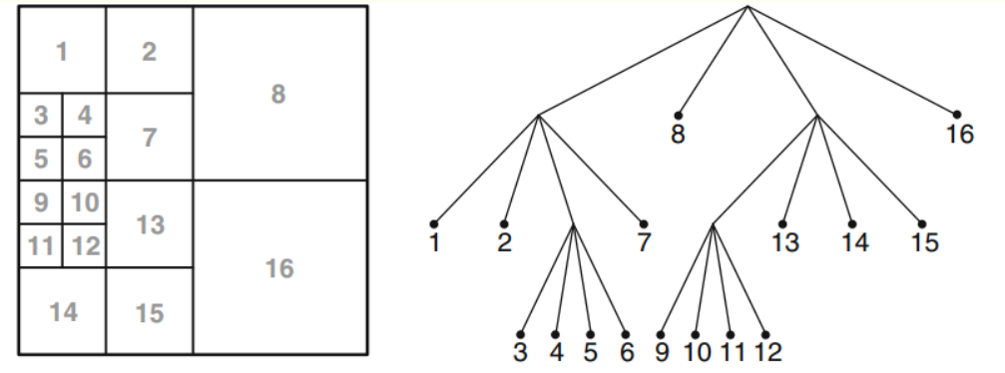
Fig. 2. Quad tree structure of CTU [3].

Prediction Units (PUs):
PUs are the smallest units to perform either intra or inter prediction. HEVC allows CU to be partitioned into PU with a maximum of “one” partition. For intra PUs, their sizes should be the same as CUs, except the minimum size CU (8x8), which can be further partitioned as four 4x4 PUs. As for inter PUs, there are eight modes available, in which four are asymmetric. N can be 4, 8, 16, 32 for the following figure.
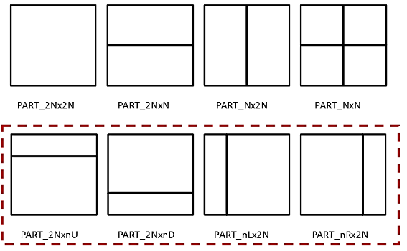
Fig. 3. 8 Segmentation methods for PUs [3].

Inter PUs follow the rules below:
1. Only 2Nx2N is allowed in skip mode
2. Asymmetric is available when CU’s size>=16
3. 4x8 and 8x4 PU is only available in single direction prediction, and is prohibited in bilateral prediction

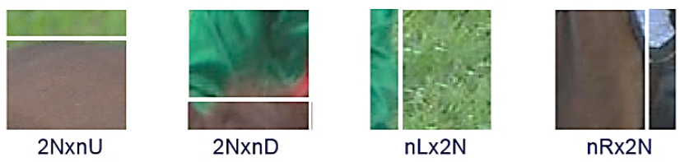
Fig. 4. Practical example of PUs’ adaptive segmentation [3].

Transform Units (TUs):
TUs are the basic units that perform integer transform and quantization. The TU structure is also a quadtree like CUs. Partitions of TUs are independent on PUs partitions. However, for intra prediction, TUs should have size smaller than that of PUs. While TUs can have sizes larger than PUs but should be smaller than CUs sizes instead in inter prediction. Larger TUs concentrates more energy and smaller TUs can conserve more details of input images.
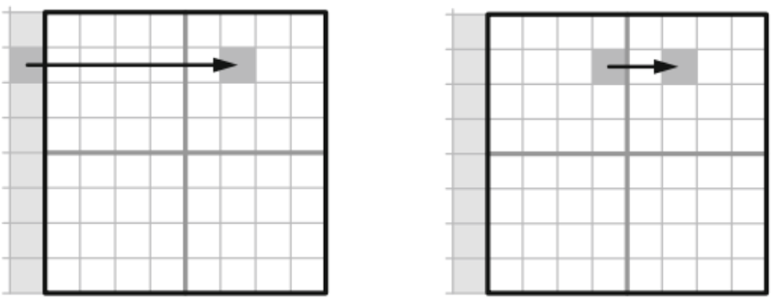
Fig. 5. explain why TUs should be smaller than PUs in intra prediction [3].

Internal Bit Depth Increase (IBDI):
Inputs’ bit depth is increased when received by encoder and is decreased to the original bit depth at the output of decoder. The method increases accuracy but require larger memory.

Intra & Inter Prediction

Intra Prediction Modes:
Support 35 modes for luma, including planar, DC, and 33 directional predict. Only 5 modes are available for chroma, which are planar, DC, vertical/horizontal and derived, which follows the same mode with luma.

Motion Vector Predict:

Spatial mode:
The spatial candidate block selection order is as follows: a1, b1, b0, a0, (b2). b2 is considered only when any of the first four are unavailable. For determining spatial candidate blocks, the following three checks need to be performed:

1. Availability: Whether encoding is complete, whether it is inter-frame.
2. Avoidance of redundant motion data from different reference blocks. However, the standard specifies that it is not necessary to check every pair of adjacent blocks. When selecting b0, only b1 needs to be checked; when selecting a0, only a1 needs to be checked; when selecting b2, only a1 and b1 need to be checked.
3. Avoid forming a 2Nx2N CU with the candidate PU and the current PU. For current PUs of Nx2N and 2NxN, a1 and b1 are respectively unavailable.

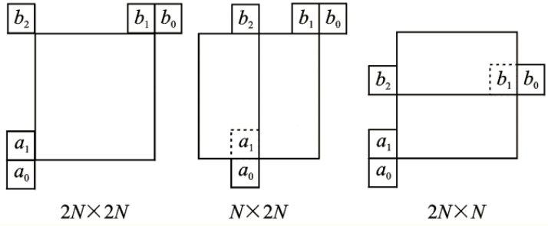
Fig. 6. MV prediction priority [3].

Temporal mode:
The current frame is Curr_pic, and the current prediction unit is also Curr_pic. The reference frame list (RPL) contains the frame Col_pic, which has the closest POC distance to the current frame. The corresponding prediction unit for Col_pic is Col_PU. For the selection of Col_PU, as shown in the top left figure, C1 is the preferred choice. If C1 is not available, then C0 is selected. The reference frames for Curr_PU and Col_PU are Curr_ref and Col_ref respectively. 'to' and 'td' represent the POC distance between the two frames, as shown in the diagram. By scaling the motion vectors MV of Col_PU based on the ratio relationship between “to” and “td”, the spatial prediction value of the motion vector for Curr_PU can be obtained.

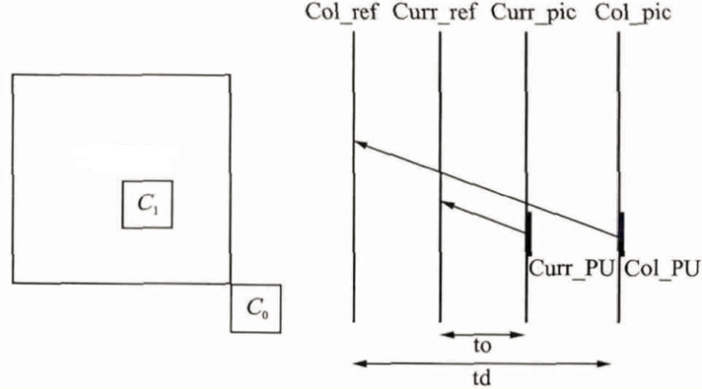
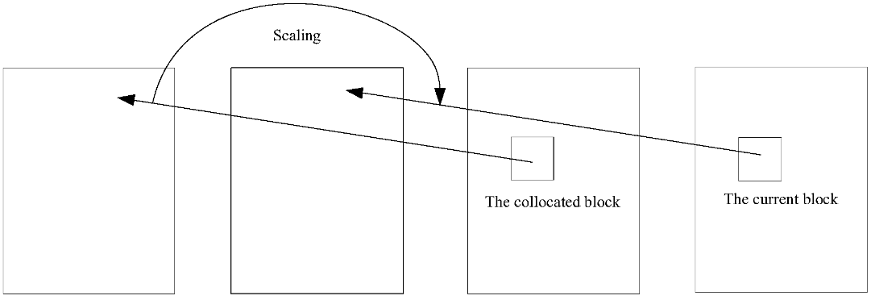
Fig. 7. Visualization of MV by temporal prediction [4].

Advanced Motion Vector Prediction (AMVP):
Select from the 5 spatially adjacent blocks, and choose the first available block from each set {a0, a1} and {b0, b1, b2} in order and add them to the candidate list. If one of the two spatially candidate motion parameter prediction values is unavailable, then a candidate motion parameter prediction value needs to be generated from the corresponding position in the temporal domain. If the temporal motion parameter prediction value is also unavailable, then it is filled with zeros to ensure that the final number of candidates is 2.

Interpolation, Deblocking Filtering, and Entropy Coding

Interpolation:
For H.264 (YUV=420):
luminance:
For 1/2 pixels, a 6-tap filter is used.
For 1/4 pel, bilinear interpolation is used, and then the 1/2 pel values are interpolated again.
chrominance:
Bilinear interpolation is used with 1/8 precision.

For HEVC:
luminance:
1/4 and 1/2 pel values are interpolated using 7-tap and 8-tap filters respectively, as specified in Table 5 [3].

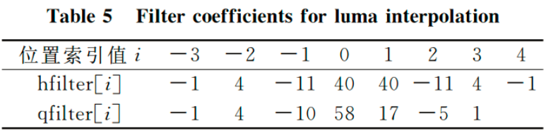

chrominance:
1/8 pel values are interpolated using 7 4-tap filters specified in Table 6 [3].

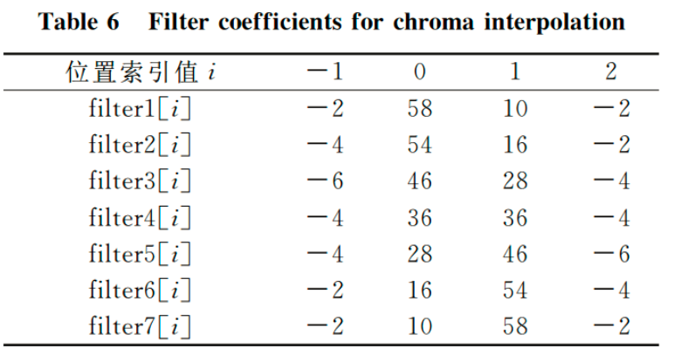

Advantages of HEVC interpolation compared to H.264:
1. Direct interpolation for 1/4 pel eliminates the need for secondary interpolation based on 1/2 pel interpolation results, thereby removing the precision loss caused by rounding during the 1/2 pel interpolation.
2. HEVC's interpolation filters are based on DCT, resulting in more accurate interpolation filters.

Sample Adaptive Offset (SAO):
Kind of deblocking filtering, aiming to eliminate or reduce the ringing effect. There are three types: no SAO, edge offset mode (EO) and band offset mode (BO).
EO: first determine which gradient mode is applied by RDO

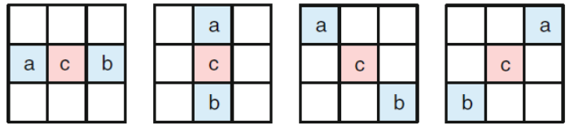
Fig. 8. Four gradient modes of EO.

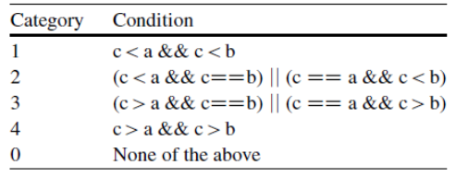
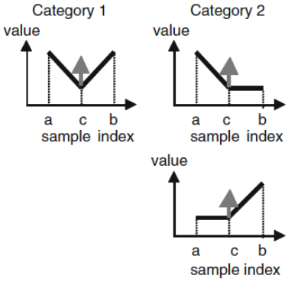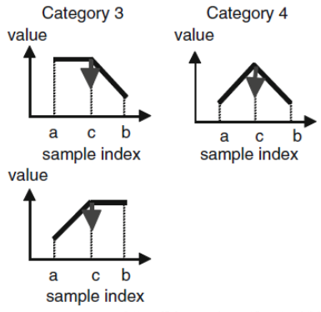
Fig. 9. Four categories and their corresponding conditions of EO [3].

sign bit of offset need not to be encoded.

BO: divide interval [0, 255] to 8 bands. Calculate the mean value of each band of original input and output. Then select 4 consecutive bands that have largest offset, and compensate the offset.
Why “4”?
1. in flat area, four bands can cover most of the pixels.
2. EO also uses 4 gradient modes. reuse it so as not to increase the bitrate.

Entropy Coding: Only CABAC for HEVC.

Wavefront Parallel Processing (WPP):
Parallel processing for faster execution time. The next row is immediately encoded once 2 CTUs of its upper row is done. The context of the current CABAC comes from the top-right CTU.

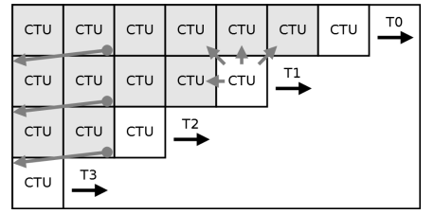
Fig. 10. Visualization of WPP [5].

Conclusion
To sum up, the biggest differences between HEVC and AVC is the size of block. Therefore, when processing high-definition videos with a resolution of 4K or higher, HEVC achieves approximately half the compressed size compared to AVC. However, in scenarios where the resolution is not as high, HEVC only slightly outperforms AVC.
In addition, the more complicated AMVP, deblocking filtering (SAO), and CABAC monopoly all increases the processing time.

References
[1] https://ottverse.com/what-are-idr-cra-frames-hevc-differences-uses/
[2] V. Sze, M. Budagavi, G. J. Sullivan, High Efficiency Video Coding (HEVC): Algorithms and Architectures. Springer, 2014.
[3] https://www.cnblogs.com/DwyaneTalk/p/5711333.html
[4] https://patents.google.com/patent/WO2016165069A1/en
[5] https://ieeexplore.ieee.org/document/7514486

More to Read
1. https://blog.csdn.net/liangjiubujiu/article/details/81128013
2. https://lazybing.github.io/blog/2021/10/16/overview-of-hevc-stand/

