Tutorial for Variational Mode Decomposition

Author:
Chieh-Hsun Hsieh (謝杰勳)
Edit by Jian-Jiun Ding

Digital Image and Signal Processing Laboratory (DISP)
Graduate Institute of Communication Engineering
National Taiwan University

January 2024

Abstract
Mode decomposition has wide-ranging applications across various fields, but their efficacy depends on the nature of the signals and the specific requirements of the analysis. Understanding the trade-offs and limitations of each technique is crucial for their successful application. Compared with the Empirical Mode Decomposition (EMD) algorithm, Variational Mode Decomposition (VMD) proposes a new Intrinsic Mode Function (IMF) definition and variational problem model, and uses the Alternate Direction Method of Multiplier (ADMM) method to perform mode decomposition, making it more robust to sampling and noise. In this tutorial, the mathematical tools used in VMD will be introduced in detail, and the comparison of algorithms in experiments will be summarized.

Content
Abstract 2
Content 3
Chapter 1. Introduction 1
Intrinsic Mode Function 2
Recent works of EMD 3
Chapter 2. Relates tools 4
Winer filtering 4
Hilbert transform and analytic signal 6
Frequency mixing and heterodyne demodulation 7
Alternate direction method of multipliers (ADMM) 8
Chapter 3. Variational Mode Decomposition 11
Proposed scheme 11
Algorithm of VMD 13
Reports of VMD 16
Recent works of VMD 18
Chapter 4. Simulation results 21
Chapter 5. Conclusions 24
References 25

Introduction
Empirical Mode Decomposition (EMD) [1] is a recursive algorithm that decomposes input signals into Intrinsic Mode Functions (IMFs) through the detection of extrema, offering a time-frequency analysis method without the need for convolution. EMD has widely applied in diverse fields such as audio engineering, climate analysis, financial time series analysis, and biomedical signal analysis.
The mode defined in EMD, requiring the number of extrema and zero crossings in the entire data set to either be equal or differ by at most one, and mandating the mean value of the envelope defined by local maxima and minima to be zero at any point, result in a methodology that may lacks robust theoretical properties. The reliance on extremum searching and interpolation further complicates the theoretical discussions and improvements of EMD, making it challenging to address or enhance further issues.
In variational mode decomposition (VMD) [2], IMF is defined based on amplitude modulation-frequency modulation (AM-FM) attributes, which is used to assume that the IMF signal has narrow-band characteristics, and methods and signal processing tools are proposed for IMF decomposition. This tutorial aims to introduce the principles and advantages of VMD. In this tutorial, the first chapter introduces the calculation of IMFs and instantaneous frequencies in VMD, along with discussions on current methods for improving EMD. The second chapter provides an overview of the mathematical tools utilized in VMD, while the third chapter delves into the algorithm proposed by VMD and related issues.

Intrinsic Mode Function
In EMD, an IMF is defined as a function that satisfies two conditions [1]:
- The number of extrema (maxima and minima) and the number of zero crossings must be equal or differ at most by one.
- At any point, the mean value of the envelope defined by the local maxima and minima is zero.
In order to consider the mode as a pure harmonic frequency signal to better handle the problem of possible mode mixing. The definition is slightly changed into so-called IMF, based on modulation criteria in [2]:
$$\begin{aligned}u_{k}\left(t\right)=A_{k}\left(t\right)\text{cos}\left({\text{ϕ}}_{\text{k}}\left(\text{t}\right)\right),\#\left( STYLEREF 1 \backslash s 1 SEQ Equation \backslash * ARABIC \backslash s 1 1\right)\end{aligned}$$
where the phase $ϕ_{k}\left(t\right)$ is a non-decreasing function, $ϕ_{k}^{'}\left(t\right)≥0$, the envelope is non-negative $A_{k}\left(t\right)≥0$. Both the envelope $A_{k}\left(t\right)$ and the instantaneous frequency $ω_{k}\left(t\right)≔ϕ_{k}^{'}\left(t\right)$ vary much slower than the phase $ϕ_{k}\left(t\right)$.
The changed definition of IMFs is slightly more restrictive than the original one [1]: while all signals adhering to the above IMF definition satisfy the original EMD mode properties, the converse is not necessarily true. If $ω_{k}\left(t\right)$ is the mean frequency of a mode, then its practical bandwidth increases both with the maximum deviation $Δf$of the instantaneous frequency from its center (carrier frequency, $f_{c}$), and with the rate of this excursion $f_{FM}$. In addition, the bandwidth of the envelope $A_{k}\left(t\right)$ modulating the amplitude of the FM signal given by its highest frequency $f_{AM}$. The total practical bandwidth of an IMF is estimated as
$$\begin{aligned}{BW}_{AM,FM}=2\left(Δf+f_{FM}+f_{AM}\right).\#\left( STYLEREF 1 \backslash s 1 SEQ Equation \backslash * ARABIC \backslash s 1 2\right)\end{aligned}$$

Recent works of EMD
EMD is a signal processing technique that decomposes a signal into IMFs. While EMD has been widely used, it has some limitations, such as mode mixing and endpoint effects. In response to these challenges, Ensemble Empirical Mode Decomposition (EEMD) [3] and Complementary Ensemble Empirical Mode Decomposition (CEEMD) [4] were introduced to enhance the performance of EMD.
EEMD was proposed as a solution to the mode mixing problem in EMD. Mode mixing occurs when different frequency components are combined into a single IMF, making it difficult to separate them accurately. EEMD involves adding white noise to the original signal and performing multiple rounds of EMD on the noisy signals. The idea is that the noise helps break the mode mixing, and by averaging the results over multiple trials, a more reliable set of IMFs is obtained. EEMD is known for its ability to reduce mode mixing, improve decomposition accuracy, and enhance the adaptability of EMD to a wider range of signals.
CEEMD takes the concept of EEMD further by introducing a complementary ensemble to deal with the endpoint effects associated with EMD. Endpoint effects refer to distortions near the boundaries of the signal caused by the finite length of the data. CEEMD combines the benefits of EEMD with a complementary ensemble that is generated by mirroring and extending the original signal. This process helps address endpoint effects and provides a more accurate representation of the signal's true characteristics. CEEMD aims to not only reduce mode mixing but also mitigate endpoint effects, leading to improved accuracy in signal decomposition, particularly for signals with finite lengths.

Relates tools
In this chapter, the mathematical tools used by VMD will be introduced.

Winer filtering
Observed signal $f_{0}\left(t\right)$, original signal $f\left(t\right)$ and additive zero mean Gaussian noise $η\left(t\right):$
$$\begin{aligned}f_{0}\left(t\right)=f\left(t\right)+ η\left(t\right).\#\left( STYLEREF 1 \backslash s 2 SEQ Equation \backslash * ARABIC \backslash s 1 1\right)\end{aligned}$$
Recovering the unknown signal $f$ is a typical ill-posed problem [5]. An ill-posed problem is a mathematical or scientific problem that does not have a unique solution or has solutions that are highly sensitive to small changes in the input or initial conditions. In contrast to well-posed problems, which have a single, stable solution, ill-posed problems often lack stability, uniqueness, or both.
There are three main criteria that characterize an well-posed problem:
- Existence: The problem must have at least one solution.
- Uniqueness: The solution should be unique; small changes in the input or initial conditions should not lead to drastically different solutions.
- Stability: The solution should vary continuously with changes in the input or initial conditions. In other words, small perturbations in the data should not result in large variations in the solution.
Ill-posed problems frequently arise in various fields such as physics, engineering, and inverse problems. Examples include:
- Inverse problems: Determining the cause from observed effects, like trying to reconstruct an image from its blurred or noisy version.
- Parameter estimation: Finding values for parameters in a mathematical model that best fit experimental data.
- Integral equations: Solving equations where the unknown function appears under an integral sign.
Handling ill-posed problems often requires regularization techniques, which involve introducing additional information or constraints to stabilize the solution. Regularization methods help prevent excessive sensitivity to noise and ensure the problem has a more well-behaved solution. Ill-posed problems challenge researchers and practitioners to develop robust and reliable approaches to extract meaningful information from incomplete or noisy data.
Tikhonov regularization [6], [7], [8], also known as ridge regularization, is a regularization technique commonly used in solving ill-posed linear inverse problems. The Tikhonov regularization problem can be formulated as follows:
$$\begin{aligned}\min_{f}\left\{{\left\|f-f_{0}\right\|}_{2}^{2}+α{\left\|Tf\right\|}_{2}^{2}\right\},\#\left( STYLEREF 1 \backslash s 2 SEQ Equation \backslash * ARABIC \backslash s 1 2\right)\end{aligned}$$
where $T$ is regularization operator and the scalar $α$ is the regularization parameter. In certain scenarios, the regularization operator may employ high-pass operators, such as a difference operator or a weighted Fourier operator, to promote smoothness when the underlying signal is presumed to be predominantly continuous. This regularization enhances the problem's conditioning, facilitating a straightforward numerical solution. Let the regularization operator be the derivative with respect to time $∂_{t}$ for recovering the unknown signal $f$:
$$\begin{aligned}\min_{f}\left\{{\left\|f-f_{0}\right\|}_{2}^{2}+α{\left\|∂_{t}f\right\|}_{2}^{2}\right\}.\#\left( STYLEREF 1 \backslash s 2 SEQ Equation \backslash * ARABIC \backslash s 1 3\right)\end{aligned}$$
It can be solved in Fourier domain by Parseval's theorem and let $∂C / ∂{\hat{f}}^{*} = 0$:
$$\begin{aligned}\hat{f}\left(ω\right)=\frac{{\hat{f}}_{0}\left(ω\right)}{1+αω^{2}},\#\left( STYLEREF 1 \backslash s 2 SEQ Equation \backslash * ARABIC \backslash s 1 4\right)\end{aligned}$$
where $C={\left\|\hat{f}-{\hat{f}}_{0}\right\|}_{2}^{2}+α{\left\|jω\hat{f}\right\|}_{2}^{2}$ is the objective function with the Tikhonov regularization in Fourier domain and $\hat{f}\left(ω\right)≜F\{f\left(t\right)\}\left(ω\right)=\int_{-∞}^{∞}{f\left(t\right)e^{-jωt}dt}$ is the Fourier transform of the signal $f\left(t\right)$. The solution corresponds to convolution with a Winer filter, where $α$ represents the variance of the white noise, and the signal has a lowpass $1/ω^{2}$ power spectrum prior [9], [10]. It benefits from smoothness assumptions on the underlying signal because regularization helps prevent overfitting to noise in the observed data. $H^{1}$ smoothness provides a mathematical framework for characterizing the regularity of functions. When considering Wiener filtering, a signal with $H^{1}$ smoothness is more likely to have well-behaved derivatives, and the regularization inherent in the Wiener filter aligns with the desire to produce smooth estimates.

Hilbert transform and analytic signal
The Hilbert transform [11] is a mathematical operation that, when applied to a real-valued signal, produces a complex-valued signal. It is defined by the convolution of the original signal with the corresponding impulse response:
$$\begin{aligned}h\left(t\right)=\frac{1}{πt}.\#\left( STYLEREF 1 \backslash s 2 SEQ Equation \backslash * ARABIC \backslash s 1 5\right)\end{aligned}$$
The Hilbert transform is denoted by $H\{∙\}$ and is commonly used to obtain the analytic signal from a real-valued signal. It is an all-pass filter that is characterized by the transfer function:
$$\begin{aligned}\hat{h}\left(ω\right)=-j\text{sgn}\left(ω\right)=\frac{-jω}{\left|ω\right|}.\#\left( STYLEREF 1 \backslash s 2 SEQ Equation \backslash * ARABIC \backslash s 1 6\right)\end{aligned}$$
The analytic signal is a complex-valued signal derived from a real-valued signal by applying the Hilbert transform. If $f(t)$ is a real-valued signal, its analytic signal $f_{A}\left(t\right)$ is given by:
$$\begin{aligned}f_{A}\left(t\right) =f\left(t\right)+jH\left\{f\left(t\right)\right\}=A\left(t\right)e^{jϕ\left(t\right)}.\#\left( STYLEREF 1 \backslash s 2 SEQ Equation \backslash * ARABIC \backslash s 1 7\right)\end{aligned}$$
The analytic signal contains information about the amplitude $A\left(t\right)$ and phase $ϕ\left(t\right)$ of the original signal. This is useful in the analysis of time-varying amplitude and instantaneous frequency. For a sinusoidal signal, the instantaneous frequency is constant, but for more general signals, it can vary with time. The instantaneous frequency $ω\left(t\right)$ of a signal $f(t)$ can be extracted from its analytic signal as follows:
$$\begin{aligned}ω\left(t\right)=\frac{d}{dt}\arg\left\{f_{A}\left(t\right)\right\}=\frac{d}{dt}ϕ\left(t\right).\#\left( STYLEREF 1 \backslash s 2 SEQ Equation \backslash * ARABIC \backslash s 1 8\right)\end{aligned}$$
where $\arg\left\{∙\right\}$ denotes the phase of the complex number $ϕ\left(t\right)$. The derivative of the phase with respect to time provides the instantaneous frequency. Each IMF can be treated as an analytic signal.
$$u_{k,A}(t)=A_{k}\left(t\right)\text{(cos}\left({\text{ϕ}}_{\text{k}}\left(\text{t}\right)\right)+j sin⁡({\text{ϕ}}_{\text{k}}\left(\text{t}\right))) \\ \begin{aligned}=A_{k}\left(t\right)e^{jϕ_{k}\left(t\right)}.\#\left( STYLEREF 1 \backslash s 2 SEQ Equation \backslash * ARABIC \backslash s 1 9\right)\end{aligned}$$
This is because an IMF is, by definition of $\left(1-1\right)$ a mono-component signal with a well-defined frequency that can be characterized by its instantaneous frequency. Therefore, an IMF can be considered as a form of localized oscillation, and its analytic signal representation can be obtained using the Hilbert transform. And the original (real) signal is easily retrieved as the real part:
$$\begin{aligned}f_{k}\left(t\right)=R\left\{f_{A}\left(t\right)\right\},\#\left( STYLEREF 1 \backslash s 2 SEQ Equation \backslash * ARABIC \backslash s 1 10\right)\end{aligned}$$

Frequency mixing and heterodyne demodulation
Frequency mixing involves combining two or more signals at different frequencies to produce new signals that contain various frequency components, including the sum and difference frequencies of the original signals.
$$\begin{aligned}2\cos\left(ω_{1}t\right)\cos\left(ω_{2}t\right)=\cos\left(\left(ω_{1}+ω_{2}\right)t\right)+\cos\left(\left(ω_{1}-ω_{2}\right)t\right),\#\left( STYLEREF 1 \backslash s 2 SEQ Equation \backslash * ARABIC \backslash s 1 11\right)\end{aligned}$$
and the two respective analytic signals are mixed as bellow:
$$\begin{aligned}e^{jω_{1}t}e^{jω_{2}t}=e^{j{(ω}_{1}+ω_{2})t}.\#\left( STYLEREF 1 \backslash s 2 SEQ Equation \backslash * ARABIC \backslash s 1 12\right)\end{aligned}$$
Heterodyne demodulation is widely used in amplitude modulation (AM) and single-sideband modulation (SSB) receivers. It provides a way to extract the modulating signal from the carrier in an efficient manner. The frequency shifting of the analytic signal is simply multiplied a pure exponential:
$$\begin{aligned}F\left\{f_{A}\left(t\right)e^{-jω_{0}t}\right\}={\hat{f}}_{A}\left(ω+ω_{0}\right),\#\left( STYLEREF 1 \backslash s 2 SEQ Equation \backslash * ARABIC \backslash s 1 13\right)\end{aligned}$$

Alternate direction method of multipliers (ADMM)
ADMM [12] is an optimization algorithm used to solve problems where the objective function is separable or can be decomposed into smaller, more manageable components. It's particularly effective for problems with multiple variables or constraints.
Considering the equality-constrained convex optimization problem:
$$\min_{x}{g\left(x\right)} \\ \begin{aligned}s.t. Ax=b,\#\left( STYLEREF 1 \backslash s 2 SEQ Equation \backslash * ARABIC \backslash s 1 14\right)\end{aligned}$$
where $g$ is strictly convex and closed. The Lagrangian for problem ($2-14$) is:
$$\begin{aligned}L\left(x,u\right)=g\left(x\right)+u^{T}\left(Ax-b\right),\#\left( STYLEREF 1 \backslash s 2 SEQ Equation \backslash * ARABIC \backslash s 1 15\right)\end{aligned}$$
Dual gradient ascent: Dual ascent is a technique used in optimization to solve problems with equality constraints. It involves iteratively updating Lagrange multipliers (dual variables) to drive the solution towards feasibility. The Dual ascent repeats for $k = 1, 2, 3, …$:
$$x^{\left(k\right)}≔{argmin}_{x}L\left(x,u^{\left(k-1\right)}\right) \\ \begin{aligned}u^{\left(k\right)}≔u^{\left(k-1\right)}+t_{k}\left(Ax^{\left(k\right)}-b\right),\#\left( STYLEREF 1 \backslash s 2 SEQ Equation \backslash * ARABIC \backslash s 1 16\right)\end{aligned}$$
where $t_{k}>0$ is a step size in step $k$. The dual ascent algorithm iteratively updates the dual variables in the direction of the gradient of the Lagrangian with respect to the dual variables.
Decomposition of the Problem: Decomposition involves breaking down a complex optimization problem into smaller, more manageable subproblems. This is particularly useful when the objective function is separable or can be expressed as a sum of functions.
$$\begin{aligned}g\left(x\right)=\sum_{i=1}^{N}{g_{i}\left(x_{i}\right)},\#\left( STYLEREF 1 \backslash s 2 SEQ Equation \backslash * ARABIC \backslash s 1 17\right)\end{aligned}$$
and the Lagrangian can be written as:
$$\begin{aligned}L\left(x,y\right)=\sum_{i=1}^{N}{L_{i}\left(x_{i},y\right)}=\sum_{i=1}^{N}{\left(g_{i}\left(x_{i}\right)+y^{T}A_{i}x_{i}-\frac{1}{N}y^{T}b\right)}.\#\left( STYLEREF 1 \backslash s 2 SEQ Equation \backslash * ARABIC \backslash s 1 18\right)\end{aligned}$$
The problem splits into $N$ separate problems that can be solved in parallel:
$${x_{i}}^{\left(k\right)}≔{argmin}_{x_{i}}L_{i}\left(x_{i},y^{\left(k-1\right)}\right) \\ \begin{aligned}y^{\left(k\right)}≔y^{\left(k-1\right)}+t_{k}\left(Ax^{\left(k\right)}-b\right).\#\left( STYLEREF 1 \backslash s 2 SEQ Equation \backslash * ARABIC \backslash s 1 19\right)\end{aligned}$$
It simplifies the optimization process by focusing on smaller components of the problem, making it easier to solve and potentially converging faster.
Augmented Lagrangian Formulation: ADMM introduces the augmented Lagrangian function, which includes the original objective function and penalty terms involving Lagrange multipliers. This augmented function helps to handle constraints and promote convergence. The augmented Lagrangian for ($2-14$) is:
$$\begin{aligned}L_{ρ}\left(x,u\right)=g\left(x\right)+u^{T}\left(Ax-b\right)+\frac{ρ}{2}{\left\|Ax-b\right\|}_{2}^{2},\#\left( STYLEREF 1 \backslash s 2 SEQ Equation \backslash * ARABIC \backslash s 1 20\right)\end{aligned}$$
where $ρ>0$ is called the penalty parameter. The modified problem is solved by applying dual ascent:
$$x^{\left(k\right)}≔{argmin}_{x}L_{ρ}\left(x,y^{\left(k-1\right)}\right) \\ \begin{aligned}y^{\left(k\right)}≔y^{\left(k-1\right)}+ρ\left(Ax^{\left(k\right)}-b\right).\#\left( STYLEREF 1 \backslash s 2 SEQ Equation \backslash * ARABIC \backslash s 1 21\right)\end{aligned}$$
In the context of ADMM, the augmented Lagrangian is used to update the Lagrange multipliers and is part of the variable update steps.
Convergence: ADMM continues these alternating updates until convergence criteria are met, such as reaching a desired level of accuracy or stability in the solution.
ADMM is favored for its ability to handle large-scale optimization problems by breaking them down into smaller, more manageable parts, and it often converges faster than other methods for certain types of problems. Its structure also makes it amenable to parallel and distributed computing, which is beneficial for large-scale applications. However, ADMM's performance can be sensitive to certain problem characteristics, and selecting appropriate penalty parameters is crucial for its convergence and efficiency.

Variational Mode Decomposition

Proposed scheme
The goal of VMD [2] is to decompose a real valued input signal $f$ into a discrete number of sub-signals (modes), $u_{k}$, that have specific sparsity properties while reproducing the input. The sparsity prior of each mode is chosen to be its bandwidth in spectral domain. In other words, we assume each mode $k$to be mostly compact around a center pulsation $ω_{k}$, which is to be determined along with the decomposition. The following scheme is proposed to assess the bandwidth of a mode:
- For each mode $u_{k}$, compute the associated analytic signal by means of the Hilbert transform in order to obtain a unilateral frequency spectrum.
- For each mode, shift the mode's frequency spectrum to “baseband”, by mixing with an exponential tuned to the respective estimated center frequency.
- The bandwidth is now estimated through the H1 Gaussian smoothness of the demodulated signal, i.e. the squared L2-norm of the gradient.
The resulting constrained variational problem is the following:
$$\begin{aligned}\min_{\{u_{k}\},\{ω_{k}\}}\left\{\sum_{k}{{\left\|∂_{t}\left[\left(δ\left(t\right)+\frac{j}{πt}\right)*u_{k}\left(t\right)\right]e^{-jω_{k}t}\right\|}_{2}^{2}}\right\},\#\left( STYLEREF 1 \backslash s 3 SEQ Equation \backslash * ARABIC \backslash s 1 1\right) \\ \text{s.t.} \sum_{k}{u_{k}}=f\end{aligned}$$
where $k=1, …, K$, $\{u_{k}\}≔\{u_{1},…,u_{K}\}$ and $\{ω_{k}\}≔\{ω_{1},…,ω_{K}\}$ are shorthand notations for the set of all modes and their center frequencies, respectively.
Lagrangian multiplier, $λ$, is a common way of enforcing constraints strictly. In addition, the quadratic penalty is a classic way to encourage reconstruction fidelity, typically in the presence of additive i.i.d. Gaussian noise. The penalty factor, $α$, is derived from such a Bayesian prior to be inversely proportional to the noise level in the data. The combination of the two terms thus benefits both from the nice convergence properties of the quadratic penalty at finite wight, and the strict enforcement of the constraint by the Lagrangian multiplier. The augmented Lagrangian $L$ as follows:
$$L\left(\{u_{k}\},\{ω_{k}\},λ\right)≔α\sum_{k}{{\left\|∂_{t}\left[\left(δ\left(t\right)+\frac{j}{πt}\right)*u_{k}\left(t\right)\right]e^{-jω_{k}t}\right\|}_{2}^{2}} \\ +{\left\|f\left(t\right)-\sum_{k}{u_{k}\left(t\right)}\right\|}_{2}^{2} \\ \begin{aligned}+\left\langle λ\left(t\right),f\left(t\right)-\sum_{k}{u_{k}\left(t\right)}\right\rangle ,\#\left( STYLEREF 1 \backslash s 3 SEQ Equation \backslash * ARABIC \backslash s 1 2\right)\end{aligned}$$
where the first term and the third term are the original problem and the Lagragian multipliers with the reconstruction constraint. The second term is the penalty term in order to construct the augmented Lagrangian $L$. The solution to the original minimization problem $\left(\text{3-1}\right)$ can be solved by ADMM algorithm, which introduced in the Chapter 2.

Algorithm of VMD
The ADMM optimization concept for VMD is as the following:
Input signal $f$, penalty factor $α$, Lagrangian multiplier update rate $τ$ and number of IMFs $K$.
Initialize $\{u_{k}^{1}\},\{ω_{k}^{1}\},λ^{1}, n←0$
repeat
$n←n+1$
for $k=1:K$ do
Update $u_{k}$:
$$\begin{aligned}u_{k}^{n+1}←\underset{u_{k}}{arg min}{L\left(\left\{u_{i<k}^{n+1}\right\},\left\{u_{i≥k}^{n}\right\},\left\{ω_{i}^{n}\right\},λ^{n}\right)}\#\left( STYLEREF 1 \backslash s 3 SEQ Equation \backslash * ARABIC \backslash s 1 3\right)\end{aligned}$$
end for
for $k=1:K$ do
Update $ω_{k}$:
$$\begin{aligned}ω_{k}^{n+1}←\underset{ω_{k}}{arg min}{L\left(\left\{u_{i<k}^{n+1}\right\},\left\{ω_{i<k}^{n+1}\right\},\left\{ω_{i≥k}^{n}\right\},λ^{n}\right)}\#\left( STYLEREF 1 \backslash s 3 SEQ Equation \backslash * ARABIC \backslash s 1 4\right)\end{aligned}$$
end for
Dual ascent:
$$\begin{aligned}λ^{n+1}←λ^{n}+τ\left(f-\sum_{k}{u_{k}^{n+1}}\right)\#\left( STYLEREF 1 \backslash s 3 SEQ Equation \backslash * ARABIC \backslash s 1 5\right)\end{aligned}$$
until convergence: $\sum_{k}{{\left\|u_{k}^{n+1} - u_{k}^{n}\right\|}_{2}^{2}}/{\left\|u_{k}^{n}\right\|}_{2}^{2}<ϵ$.
The respective subproblems of $u_{k}$ and $ω_{k}$ can be solved as the following equivalent minimization problems. For the updating the mode $u_{k}$, the subproblem $\left( STYLEREF 1 \backslash s 33\right)$ is rewritten as the following:
$$\begin{aligned}u_{k}^{n+1}←\underset{u_{k}}{arg min}\left\{{α\left\|∂_{t}\left[\left(δ\left(t\right)+\frac{j}{πt}\right)*u_{k}\left(t\right)\right]e^{-jω_{k}t}\right\|}_{2}^{2}+{\left\|f\left(t\right)-\sum_{i}{u_{i}\left(t\right)}+\frac{λ\left(t\right)}{2}\right\|}_{2}^{2}\right\},\#\left( STYLEREF 1 \backslash s 3 SEQ Equation \backslash * ARABIC \backslash s 1 6\right)\end{aligned}$$
Making use of the Parseval Fourier isometry under the $L^{2}$ norm, this problem can be solved in spectral domain:
$$\begin{aligned}{\hat{u}}_{k}^{n+1}←\underset{{\hat{u}}_{k}}{arg min}\left\{{α\left\|jω\left[\left(1+\text{sgn}\left(ω+ω_{k}\right)\right){\hat{u}}_{k}\left(ω+ω_{k}\right)\right]\right\|}_{2}^{2}+{\left\|\hat{f}\left(ω\right)-\sum_{i}{{\hat{u}}_{i}\left(ω\right)}+\frac{\hat{λ}\left(ω\right)}{2}\right\|}_{2}^{2}\right\},\#\left( STYLEREF 1 \backslash s 3 SEQ Equation \backslash * ARABIC \backslash s 1 7\right)\end{aligned}$$
Changing the variable $ω←ω-ω_{k}$ in the first term and exploiting the Hermitian symmetry of the real signals in the reconstruction fidelity term, it can write both terms as half-space integrals over thee non-negative frequencies:
$$\begin{aligned}{\hat{u}}_{k}^{n+1}←\underset{{\hat{u}}_{k}}{arg min}\left\{\int_{0}^{∞}{4α{\left(ω-ω_{k}\right)}^{2}{\left|{\hat{u}}_{k}\left(ω\right)\right|}^{2}+2{\left|\hat{f}\left(ω\right)-\sum_{i}{{\hat{u}}_{i}\left(ω\right)}+\frac{\hat{λ}\left(ω\right)}{2}\right|}^{2}dω}\right\},\#\left( STYLEREF 1 \backslash s 3 SEQ Equation \backslash * ARABIC \backslash s 1 8\right)\end{aligned}$$
The solution of this quadratic optimization is:
$$\begin{aligned}{\hat{u}}_{k}^{n+1}\left(ω\right) = \frac{\hat{f}\left(ω\right)-\sum_{i≠k}{{\hat{u}}_{i}\left(ω\right)}+\frac{\hat{λ}\left(ω\right)}{2}}{1+2α{\left(ω-ω_{k}\right)}^{2}},\#\left( STYLEREF 1 \backslash s 3 SEQ Equation \backslash * ARABIC \backslash s 1 9\right)\end{aligned}$$
which is identified as a Wiener filter of the current residual, with signal prior ${1/\left(ω-ω_{k}\right)}^{2}$. The mode in time domain is obtained as the real part of the inverse Fourier transform of this filtered analytic signal. For the center frequencies $ω_{k}$, the optimization do not appear in the reconstruction fidelity term:
$$\begin{aligned}ω_{k}^{n+1}←\underset{{\hat{u}}_{k}}{arg min}\left\{\int_{0}^{∞}{{\left(ω-ω_{k}\right)}^{2}{\left|{\hat{u}}_{k}\left(ω\right)\right|}^{2}dω}\right\}.\#\left( STYLEREF 1 \backslash s 3 SEQ Equation \backslash * ARABIC \backslash s 1 10\right)\end{aligned}$$
The quadratic problem is solved as:
$$\begin{aligned}ω_{k}^{n+1}=\frac{\int_{0}^{∞}{ω{\left|{\hat{u}}_{k}\left(ω\right)\right|}^{2}dω}}{\int_{0}^{∞}{{\left|{\hat{u}}_{k}\left(ω\right)\right|}^{2}dω}}.\#\left( STYLEREF 1 \backslash s 3 SEQ Equation \backslash * ARABIC \backslash s 1 11\right)\end{aligned}$$
The carrier frequency is the frequency of a least square linear regression to the instantaneous phase observed in the mode. Plugging the solutions of the sub-optimizations into the ADMM algorithm, and directly optimizing in Fourier domain.
The complete algorithm for VMD is optimized in Fourier domain as the following:
Input signal $f$, penalty factor $α$, Lagrangian multiplier update rate $τ$ and number of IMFs $K$.
Initialize $\{{\hat{u}}_{k}^{1}\},\{ω_{k}^{1}\},{\hat{λ}}^{1}, n←0$
repeat
$n←n+1$
for $k=1:K$ do
Update $u_{k}$:
$$\begin{aligned}{\hat{u}}_{k}^{n+1}\left(ω\right) = \frac{\hat{f}\left(ω\right)-\sum_{i≠k}{{\hat{u}}_{i}\left(ω\right)}+\frac{\hat{λ}\left(ω\right)}{2}}{1+2α{\left(ω-ω_{k}\right)}^{2}},\#\left( STYLEREF 1 \backslash s 3 SEQ Equation \backslash * ARABIC \backslash s 1 12\right)\end{aligned}$$
end for
for $k=1:K$ do
Update $ω_{k}$:
$$\begin{aligned}ω_{k}^{n+1}=\frac{\int_{0}^{∞}{ω{\left|{\hat{u}}_{k}\left(ω\right)\right|}^{2}dω}}{\int_{0}^{∞}{{\left|{\hat{u}}_{k}\left(ω\right)\right|}^{2}dω}}\#\left( STYLEREF 1 \backslash s 3 SEQ Equation \backslash * ARABIC \backslash s 1 13\right)\end{aligned}$$
end for
Dual ascent:
$$\begin{aligned}{\hat{λ}}^{n+1}\left(ω\right)←{\hat{λ}}^{n}\left(ω\right)+τ\left(\hat{f}\left(ω\right)-\sum_{k}{{\hat{u}}_{k}^{n+1}\left(ω\right)}\right)\#\left( STYLEREF 1 \backslash s 3 SEQ Equation \backslash * ARABIC \backslash s 1 14\right)\end{aligned}$$
until convergence: $\sum_{k}{{\left\|{\hat{u}}_{k}^{n+1} - {\hat{u}}_{k}^{n}\right\|}_{2}^{2}}/{\left\|{\hat{u}}_{k}^{n}\right\|}_{2}^{2}<ϵ$.
The role of the Lagrangian multiplier $λ$ is to enforce the constraint. In the strong noise cases, it should not be included in the decomposition. Dropping the Lagrangian multiplier would be the appropriate choice. The Lagrangian multiplier can be shut-off by choosing update rate $τ=0$. And the quadratic penalty $α$ represents the least-squares data fidelity prior associated with additive Gaussian noise.

Reports of VMD
In the VMD [2] evaluation report, a comparison of VMD algorithm parameter settings and a comparison with EMD was performed. Here we briefly describe the experimental results in Table 3-1 and Table 3-2.
Table 3-1 An overview of comparison with parameters in [2].
 | EMD | VMD
Pure tone signal | The error quadratic increase with frequency. | The error does not correlate with the frequency except for frequencies very close to the Nyquist frequency.
Tones separation | Cannot be separated correctly where the two signals are too close in frequency. | Good tones separation almost everywhere except for frequency too close to the Nyquist frequency.
Noise robustness | The original tones are almost unrecognizable and may be dispersed among the different components. | Can successfully decompose tones but may still be affected by noise.
Initialization | N/A | Convergence can be achieved at almost any initial value under low noise conditions.
Number of modes $K$ | N/A | Too few modes $K$: adjacent frequencies will be combined based on $α$.  Too many modes $K$: there will be multiple modes with the same spectrum characteristics.
Table 3-2 An overview of comparison in [2] for non-stationary signals.
 | EMD | VMD
Signals with linear trend | Good modes and trend separation. | Better modes and trend separation with less spurious oscillations.
Signals with quadratic trend | Better recovering the quadratic trend. | Good modes and trend separation.
Sharp transition between two constant frequencies | Unable to separate the two pieces of the piecewise constant frequency. | Good modes separation in each piecewise-constant frequency signal.
Superposition of two sawtooth signals of different period and amplitude | Unable to correctly extract the highest frequency oscillations, even though they are consistent with the definition of the original IMF in [1]. | The relevant center frequency is captured, and the resulting signal separation effect is relatively good, although it conflicts with the narrow-band assumption defined by the new IMF in [2].
Real signal from an electrocardiogram (ECG) | N/A | A “clean” ECG signal can be reconstructed by summing all but the first and last VMD modes, thus discarding the low-frequency baseline oscillation and most of the high-frequency noise.

The comparison of many parameters and experimental settings shows the advantages of the VMD algorithm. The IMF contained in the signal can be decomposed successfully under the assumption. In addition, in the Fourier spectrum, two non-overlapping signals are orthogonal, so the algorithm proposed by VMD can obtain better orthogonal properties by decomposing it in the Fourier domain.
Even so, there is still room for improvement and unavoidable shortcomings. Possible future prospects are as follows:
- Boundary effect: For practical use cases, signals are not always smooth and periodic. The Fourier analysis method requires the assumption of periodicity of the signal. Therefore, the occurrence of signal onset or the boundary of a finite time signal will violate the IMF narrowband definition.
- Non stationary signal: For real signals recorded over a long period of time, the frequency spectrum of the mode may change even more over time. The results of the decomposition may therefore overlap, as with the original Fourier analysis. Short-time Fourier analysis is a classic approach to filtering on the time axis.
- Number of modes: There are shortcomings common to many successful clustering and segmentation algorithms, such as k-means, Empirical Wavelet Transformation, etc.

Recent works of VMD
In this section, some improvements to VMD will be introduced. Since VMD [2] is designed based on the assumption of narrow-band characteristics, large frequency changes or non-stationary signals may be overly decomposed into multiple modes or difficult to process. Mode decomposition of broadband signals such as nonlinear chirp signals was proposed by Variational Nonlinear Chirp Mode Decomposition (VNCMD) [13]. It is helpful to analyze and apply signals generated in the real world.
In VNCMD, Nonlinear Chirp Mode (NCM) is defined for the AM-FM signal of the IMF as following:
$$g_{k}\left(t\right)=A_{k}\left(t\right)\text{cos}\left({\text{ϕ}}_{\text{k}}\left(\text{t}\right)\right) \\ \begin{aligned}=A_{k}\left(t\right)\text{cos}\left(\int_{0}^{t}{ω_{k}\left(s\right)ds}+ \text{ϕ}\right),\#\left( STYLEREF 1 \backslash s 3 SEQ Equation \backslash * ARABIC \backslash s 1 15\right)\end{aligned}$$
The definition is the same as the original IMF in $\left(11\right)$, but the difference is that the instantaneous frequency of its mode is not necessarily a constant and is relatively broadband. The demodulation scheme is illustrated in Fig. 3-1.
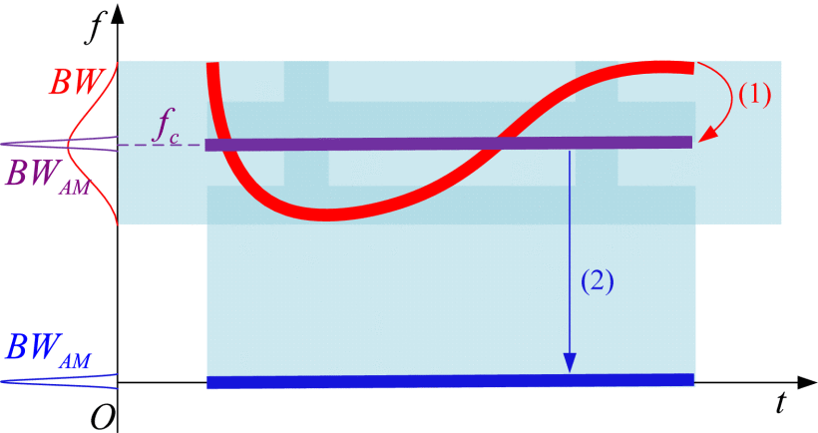
Fig. 3-1 Illustration of the demodulation scheme (the red, purple, and blue lines stand for the IF curves of the original, demodulated and baseband signals, respectively) [13].
In order to make the bandwidth after demodulation as narrow as possible, $u_{k}\left(t\right)$ and $v_{k}\left(t\right)$ are two demodulation signals given as:
$$\begin{aligned}u_{k}\left(t\right)=A_{k}\left(t\right)\text{cos}\left(\int_{0}^{t}{\left(ω_{k}\left(s\right)-{\tilde{ω}}_{k}\left(s\right)\right)ds}+ϕ_{k}\right),\#\left( STYLEREF 1 \backslash s 3 SEQ Equation \backslash * ARABIC \backslash s 1 16\right)\end{aligned}$$
$$\begin{aligned}v_{k}\left(t\right)=-A_{k}\left(t\right)\text{sin}\left(\int_{0}^{t}{\left(ω_{k}\left(s\right)-{\tilde{ω}}_{k}\left(s\right)\right)ds}+ϕ_{k}\right),\#\left( STYLEREF 1 \backslash s 3 SEQ Equation \backslash * ARABIC \backslash s 1 17\right)\end{aligned}$$
where ${\{\tilde{ω}}_{k}\left(t\right):k=1,…,K\}$ represent the frequency functions of demodulation operators. Then, it can formulate the decomposition problem as:
$$\begin{aligned}\begin{aligned}\min_{\{u_{k}\},\{v_{k}\},\{{\tilde{ω}}_{k}\}}\left\{\sum_{k}{\left({\left\|u_{k}^{''}\left(t\right)\right\|}_{2}^{2}+{\left\|v_{k}^{''}\left(t\right)\right\|}_{2}^{2}\right)}\right\}, \\ \text{s.t.} {\left\|f\left(t\right)-\sum_{k}{\left(\begin{aligned}u_{k}\left(t\right)\text{cos}\left(\int_{0}^{t}{{\tilde{ω}}_{k}\left(s\right)ds}+ \text{ϕ}\right) \\ +v_{k}\left(t\right)\text{sin}\left(\int_{0}^{t}{{\tilde{ω}}_{k}\left(s\right)ds}+ \text{ϕ}\right)\end{aligned}\right)}\right\|}_{2}≤ε\end{aligned},\#\left( STYLEREF 1 \backslash s 3 SEQ Equation \backslash * ARABIC \backslash s 1 18\right)\end{aligned}$$
where the square of the $l_{2}$ norm of the second-order derivative is used to evaluate the signal bandwidth, $ε>0$ is an upper bound determined by the noise level. This indicates that the method simultaneously searches for the demodulated signals $u_{k}\left(t\right)$ and $v_{k}\left(t\right)$ have the narrowest bands. By improving the ADMM algorithm, the broadband signal is effectively decomposed into a superposition of NCM by VNCMD [13] [14].
For mode decomposition in multi-variable or multi-channel data, Multivariate Variational Mode Decomposition (MVMD) [15] is proposed to find the joint or common mode components between all channels, such as the separation of alpha rhythms in multivariate electroencephalogram (EEG) data and the decomposition of bivariate cardiotocographic signals that consist of fetal heart rate and maternal uterine contraction (FHR-UC) as its two channels.
The main goal of MVMD is to extract predefined $K$ number of multivariate modulated modes $u_{k}\left(t\right)$ from input data $x(t)$ containing $C$ number of data channels, i.e. $x\left(t\right)=\left[x_{1}\left(t\right),x_{2}\left(t\right),…,x_{C}\left(t\right)\right]$:
$$\begin{aligned}x\left(t\right)=\sum_{k}{u_{k}\left(t\right)},\#\left( STYLEREF 1 \backslash s 3 SEQ Equation \backslash * ARABIC \backslash s 1 19\right)\end{aligned}$$
where $u_{k}\left(t\right)=\left[u_{1}\left(t\right),u_{2}\left(t\right),…,u_{C}\left(t\right)\right]$. The goal is to extract an ensemble of multivariate modulated oscillations in input data such that: i) the sum of bandwidths of the extracted modes is minimum and ii) the sum of the extracted modes exactly recover the original signal $u_{k}\left(t\right)$. The method proposed in MVMD [15] [16] is similar to the ADMM algorithm solution in VMD [2].
Research on VMD-related technologies not only focuses on the robustness of mode decomposition, but also enables better time-frequency analysis of the instantaneous frequency in each mode, which is beneficial to applications in various fields.

Simulation results
In this chapter, this tutorial uses variational mode decomposition provided by Wavelet Toolbox in MATLAB [17] to perform simulation comparisons. Here, for the simulation of tones separation, the input signal is composed of two different frequency signals $x_{1}\left(t\right)$ and $x_{2}\left(t\right)$ affected by noise:
$$\begin{aligned}x\left(t\right)=x_{1}\left(t\right)+x_{2}\left(t\right)+n\left(t\right),\#\left( STYLEREF 1 \backslash s 4 SEQ Equation \backslash * ARABIC \backslash s 1 1\right)\end{aligned}$$
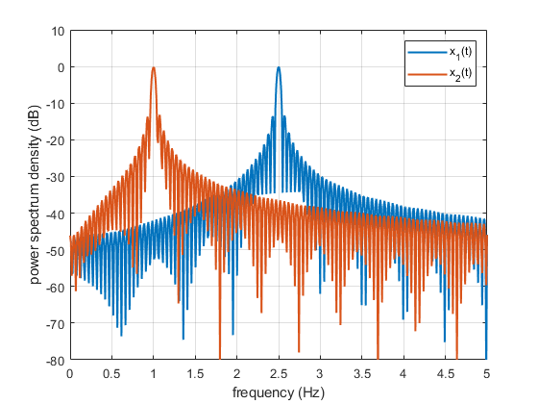
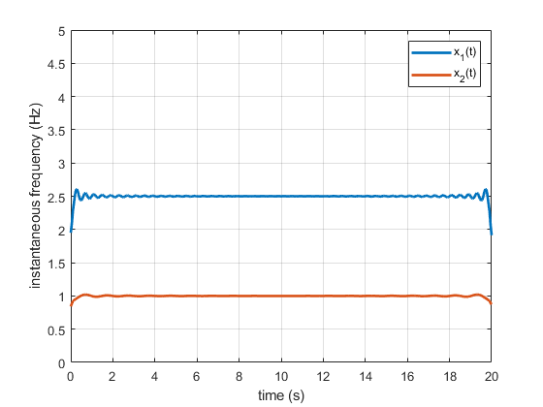
where $x_{1}\left(t\right)=\cos\left(2πf_{1}t+ϕ_{1}\right)$ and $x_{2}\left(t\right)=\cos\left(2πf_{2}t+ϕ_{2}\right)$ are pure harmonic signals as Fig 4-1; $n\left(t\right)\sim N\left(0,σ^{2}\right)$ is the Gaussian additive noise. We set the frequency $f_{1}=2.5$, $f_{2}=1$ and the noise level $σ^{2}=1$. The penalty factor $α$ is set to default value ${10}^{3}$ in [17] and the number of IMF is set as known $K=2$.
Fig 4-1 The instantaneous frequency estimated by Hilbert spectrum (left) and the estimated power spectrum density (right) of $x_{1}\left(t\right)$ and $x_{2}\left(t\right)$.
After decomposition by VMD, it can be seen that although the decomposed IMFs correspond to the correct frequency, the estimated instantaneous frequency is affected by noise as shown in Fig 4-2.

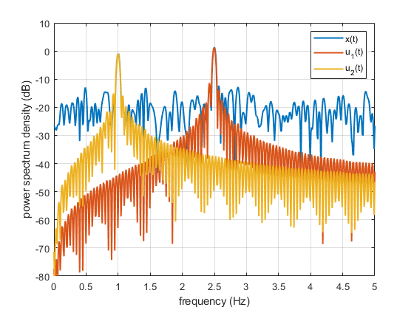
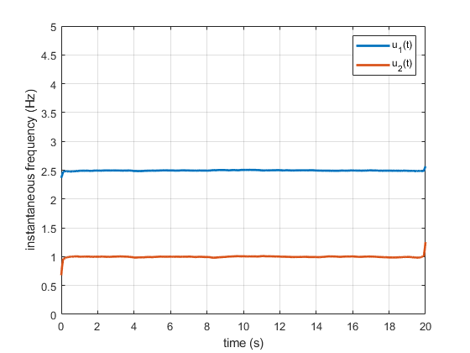
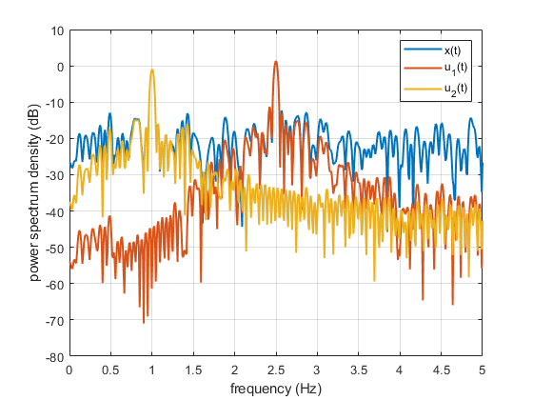
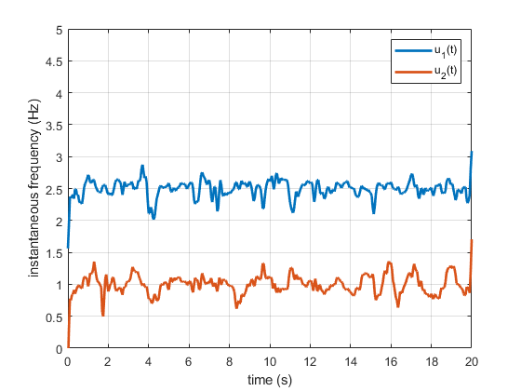
The parameter penalty factor in the VMD algorithm can be used to adjust the fidelity of the decomposed IMF. Since the input signal is affected by noise, the penalty factor can be set higher to resist the influence of noise. It can be seen that the estimation of instantaneous frequency in Fig 4-3 has better results.
Fig 4-2 The instantaneous frequency estimated by Hilbert spectrum (left) and the estimated power spectrum density (right) of decomposed IMF $u_{1}\left(t\right)$ and $u_{2}\left(t\right)$ where penalty factor $α={10}^{5}$.
Fig 4-3 The instantaneous frequency estimated by Hilbert spectrum (left) and the estimated power spectrum density (right) of decomposed IMF $u_{1}\left(t\right)$ and $u_{2}\left(t\right)$ where penalty factor $α={10}^{3}$.

We conduct experiments on the impact of penalty factor and noise to observe the decomposition performance of different choices of penalty factor under different noise levels. The relative error is defined as:
$$\begin{aligned}e_{k}=\frac{{\left\|x_{k}\left(t\right)-u_{k}\left(t\right)\right\|}_{2}}{{\left\|x_{k}\left(t\right)\right\|}_{2}}.\#\left( STYLEREF 1 \backslash s 4 SEQ Equation \backslash * ARABIC \backslash s 1 2\right)\end{aligned}$$
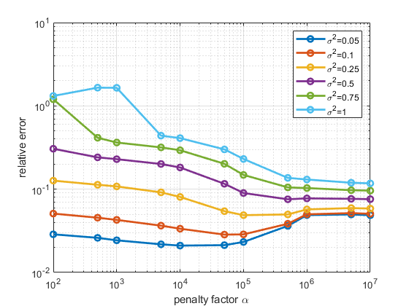
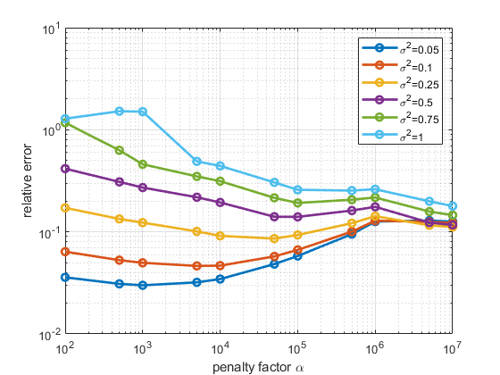
It can be seen in Fig 4-4 that a larger penalty factor can have a lower relative error under the influence of larger noise. Under the influence of lower noise, a larger penalty factor will cause a larger relative error. Therefore, the selection of penalty factor can be set based on the noise estimate of the input signal to obtain better decomposition results.
Fig 4-4 The relative error between $x_{1}\left(t\right)$ and $u_{1}\left(t\right)$ (left) and the relative error between $x_{2}\left(t\right)$ and $u_{2}\left(t\right)$ (right).

Conclusions
Mode decomposition is used in many scenarios to decompose a limited number of IMFs and easily extract the instantaneous frequency from the phase. In EMD, data is sifted iteratively until it meets the conditions of IMF. It is more difficult to deal with situations affected by noise interference and overlapping modes. In VMD, using AM-FM signals to more strictly define the IMF, the problem of decomposing modes is solved using the ADMM method. For each mode, Wiener filtering is performed on the Fourier domain to obtain a solution with limited bandwidth. The VMD scheme outperforms EMD with regards to tone detection, tone separation, and noise robustness in experimental results.
This tutorial introduces the mathematical tools and algorithms used in VMD in detail, and summarizes the performance comparison in experimental scenarios. In many application scenarios, there are still issues worthy of discussion in the research topic of mode decomposition.

References
[1] | Norden E. Huang, Zheng Shen, Steven R. Long, Manli C. Wu, Hsing H. Shih, Quanan Zheng, Nai-Chyuan Yen, Chi Chao Tung and Henry H, “The empirical mode decomposition and the Hilbert spectrum for nonlinear and non-stationarytime series analysis,” Proc. Royal Soc. A: Math. Phys. Eng. Sci., vol. 454, no. 1971, pp. 903-995, Mar. 1998.
[2] | K. Dragomiretskiy and D. Zosso, “Variational Mode Decomposition,” IEEE Transactions on Signal Processing, vol. 62, no. 3, pp. 531-544, 1 Feb. 2014.
[3] | Zhaohua Wu, Norden E. Huang, “Ensemble empirical mode decomposition: a noise-assisted data analysis method,” Advances in adaptive data analysis, vol. 1, no. 01, pp. 1-41, 2009.
[4] | Jia-Rong Yeh, Jiann-Shing Shieh, Norden E. Huang, “Complementary Ensemble Empirical Mode Decomposition: A Novel Noise Enhanced Data Analysis Method,” Advances in Adaptive Data AnalysisVol. 02, No. 02, p. 1359156, 2010.
[5] | M. Bertero, T. A. Poggio and V. Torre, “Ill-posed problems in early vision,” Proc. IEEE, vol. 76, no. 8, pp. 869-889, 1988.
[6] | V. A. Morozov, “Linear and nonlinear ill-posed problems,” J. Math. Sci., vol. II, no. 6, pp. 706-736, 1975.
[7] | Martin Fuhry, and Lothar Reichel, “A new Tikhonov regularization method,” Numerical Algorithms, pp. 433-445, 2012.
[8] | Reichel, Lothar, and Qiang Ye, “Simple square smoothing regularization operators,” Electron. Trans. Numer. Anal 33, pp. 63-83, 2009.
[9] | N. Winer, Extrapolation Interpolation and Smoothing of Stationary Time Series With Engineering Applications, USA, MA, Cambridge: Technology Press of Mass. Inst. of Technol, 1949.
[10] | R. C. Gonzalez and R. E. Woods, Digital Image Processing, USA, MA, Reading: Addison-Wesley, 1992.
[11] | M. Unser, D. Sage and D. Van De Ville, “Multiresolution monogenic signal analysisusing the Riesz–Laplace wavelet transform,” IEEE Trans. Image Process., vol. 18, no. 11, pp. 2402-2418, 2009.
[12] | S. Boyd, N. Parikh, E. Chu and B. Peleato and J., “Distributed Optimization and Statistical Learning via the Alternating Direction Method of Multipliers,” Foundations and Trends® in Machine Learning: Vol. 3: No. 1, pp. 1-122, 2011.
[13] | S. Chen, X. Dong, Z. Peng, W. Zhang and G. Meng, “Nonlinear Chirp Mode Decomposition: A Variational Method,” IEEE Transactions on Signal Processing, vol. 65, no. 22, 2017.
[14] | shiqian chen, “variational nonlinear chirp mode decomposition,” MATLAB Central File Exchange. Available: https://www.mathworks.com/matlabcentral/fileexchange/64292-variational-nonlinear-chirp-mode-decomposition.
[15] | N. u. Rehman and H. Aftab, “Multivariate Variational Mode Decomposition,” IEEE Transactions on Signal Processing, vol. 67, no. 23, pp. 6039 - 6052, 2019.
[16] | Naveed ur Rehman, “Multivariate Variational Mode Decomposition (MVMD),” MATLAB Central File Exchange. Available: https://www.mathworks.com/matlabcentral/fileexchange/72814-multivariate-variational-mode-decomposition-mvmd.
[17] | The MathWorks Inc., “variational mode decomposition,” The MathWorks Inc.. Available: https://www.mathworks.com/help/wavelet/ref/vmd.html.

